**Lab 8**

**R. Harini**

**18BCE1010**

1. **What is the percent of total Sales for Home Office in July of 2013?**

Since Home Office is only available in November of 2017, I have plotted all the product sales during that time.

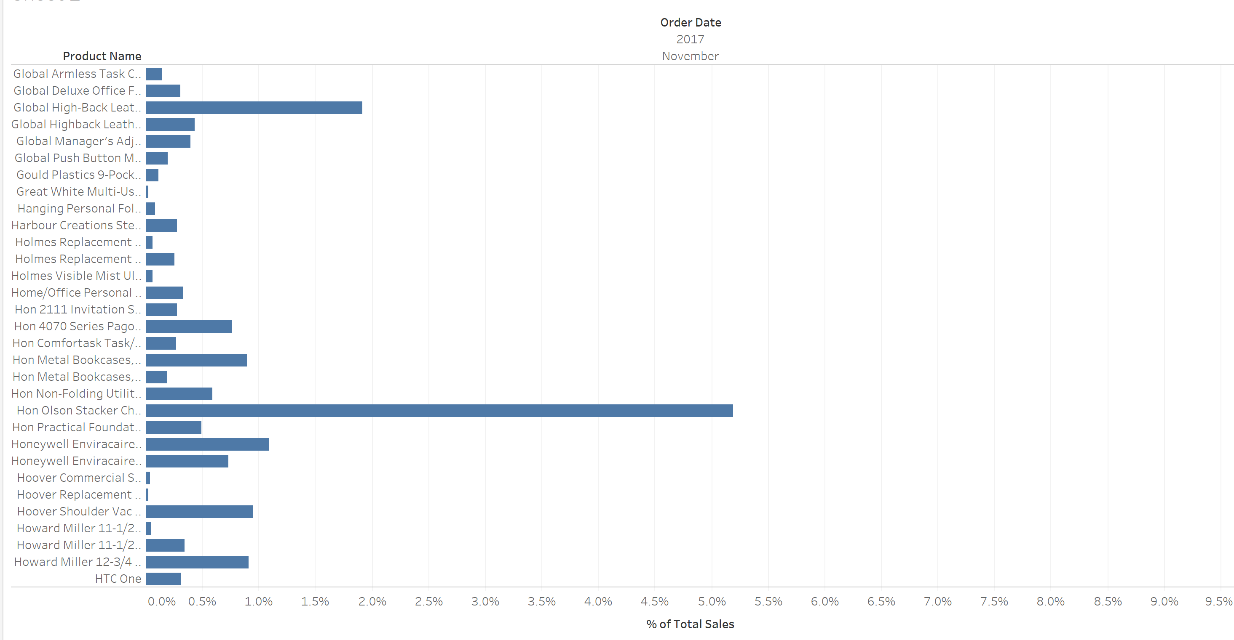

**Ans:**  0.329%

1. **Find the customer with the lowest overall profit. What is his/her profit ratio?**

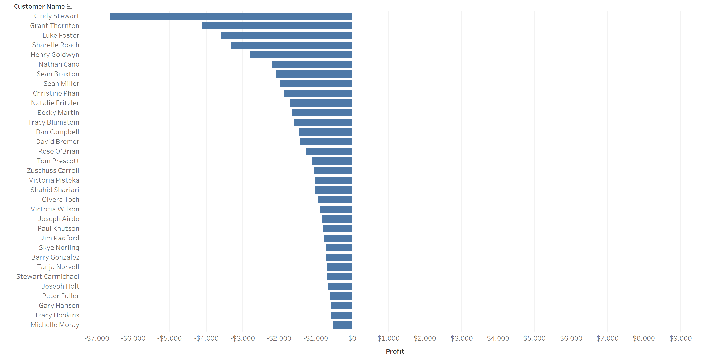

**Ans:**  Cindy Stewart

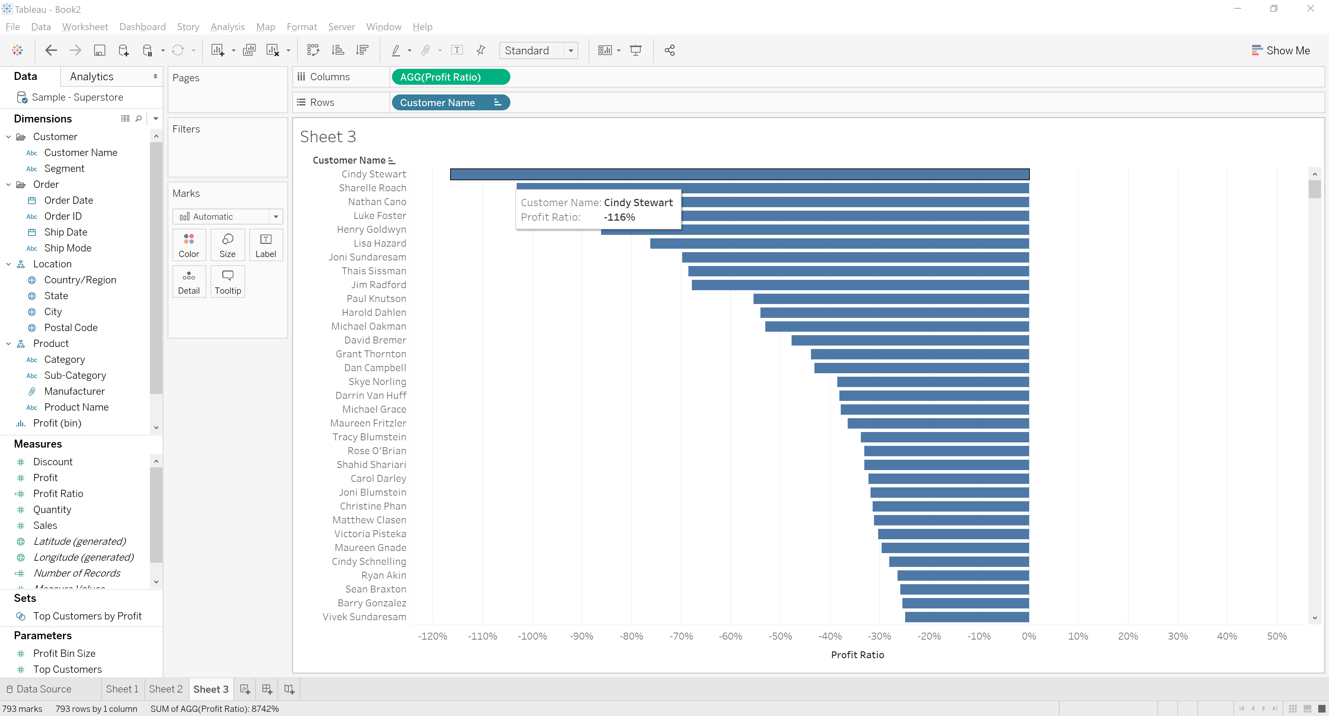

**Ans:** Profit ratio is -116%

1. **Look at the sum of profits for each category. Which category is -$31,069 below the average profit across all categories?**

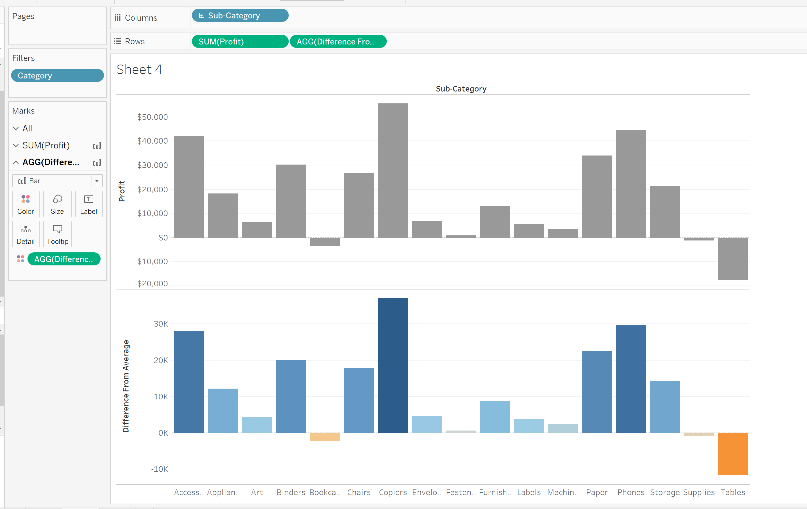

**Ans:** Tables

**Exploring Tableau:**

1. **Sum of Sales in all states**

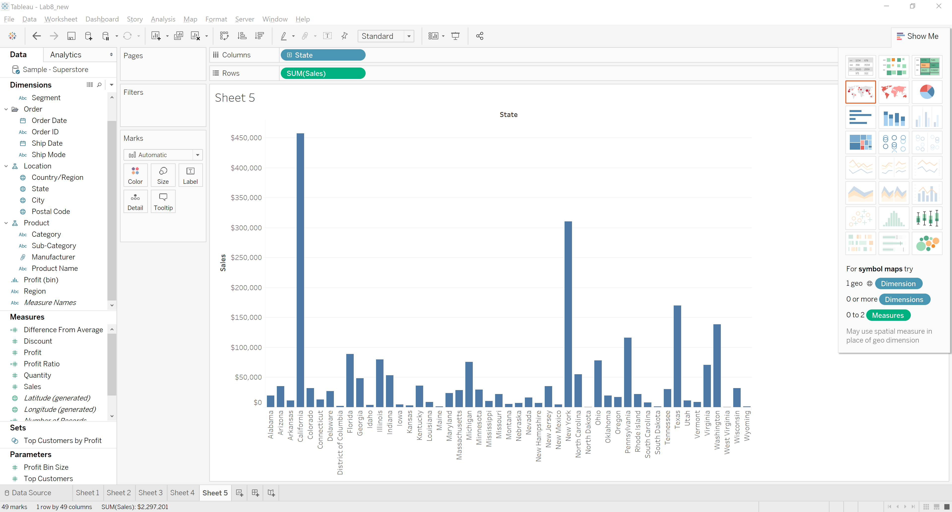

**Using Maps**

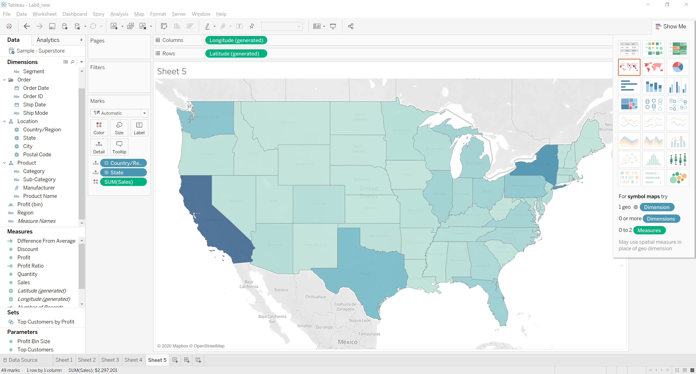

**Using Tree maps**

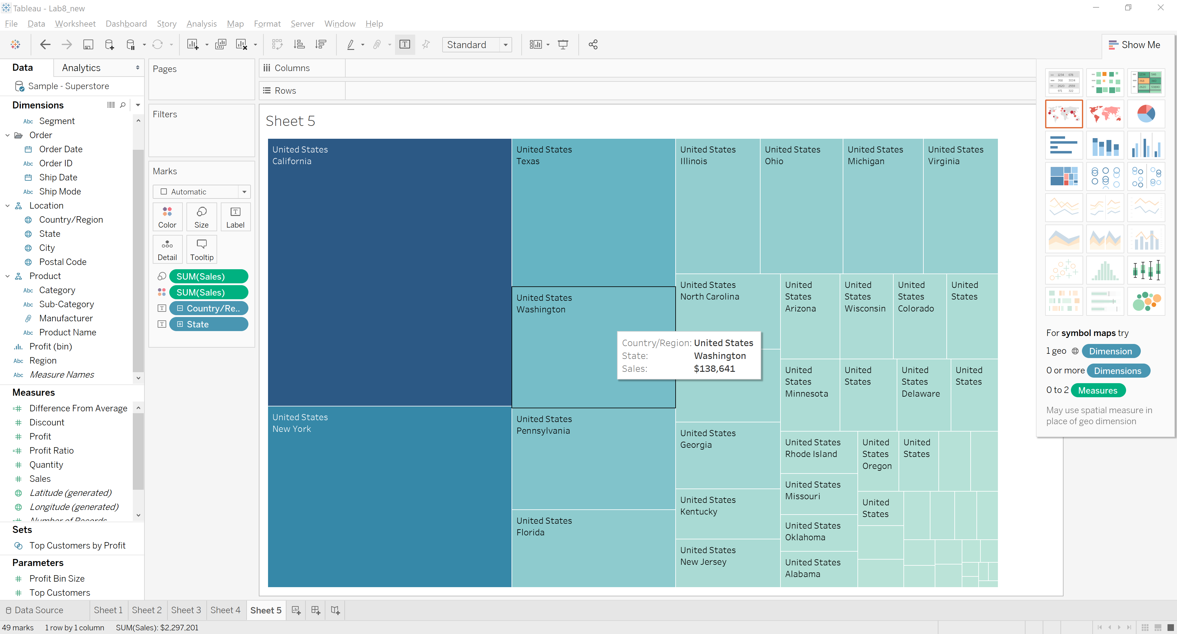

1. **Profit ratio in various States (different colors allotted to different countries)**

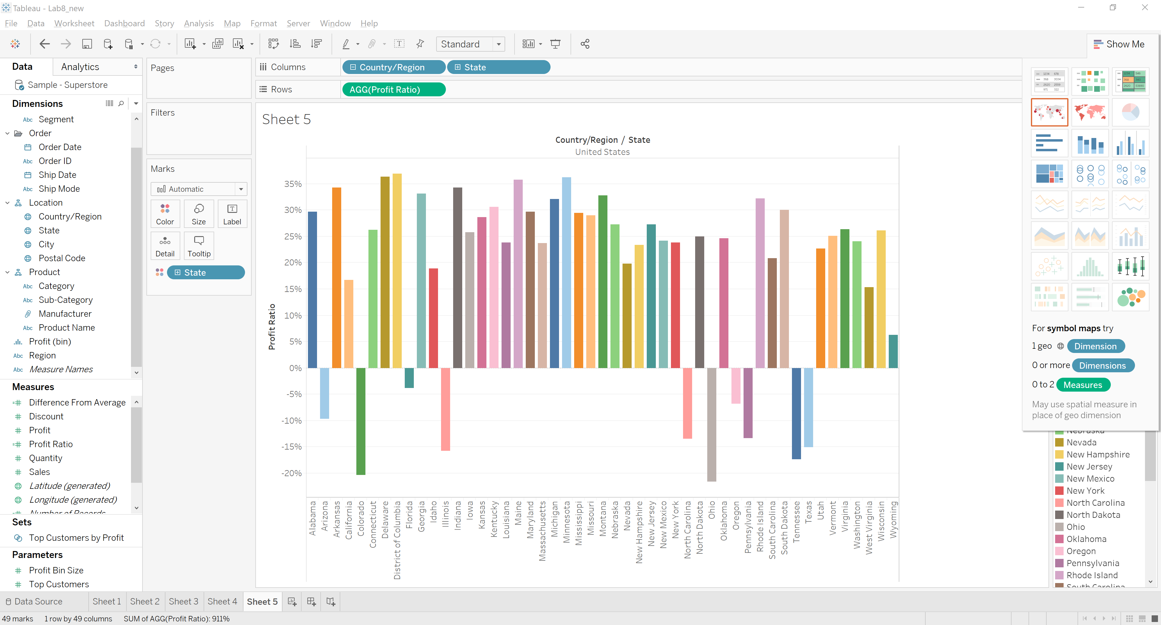

1. **Average Discount received by each Customer from each State (using highlight tables)**

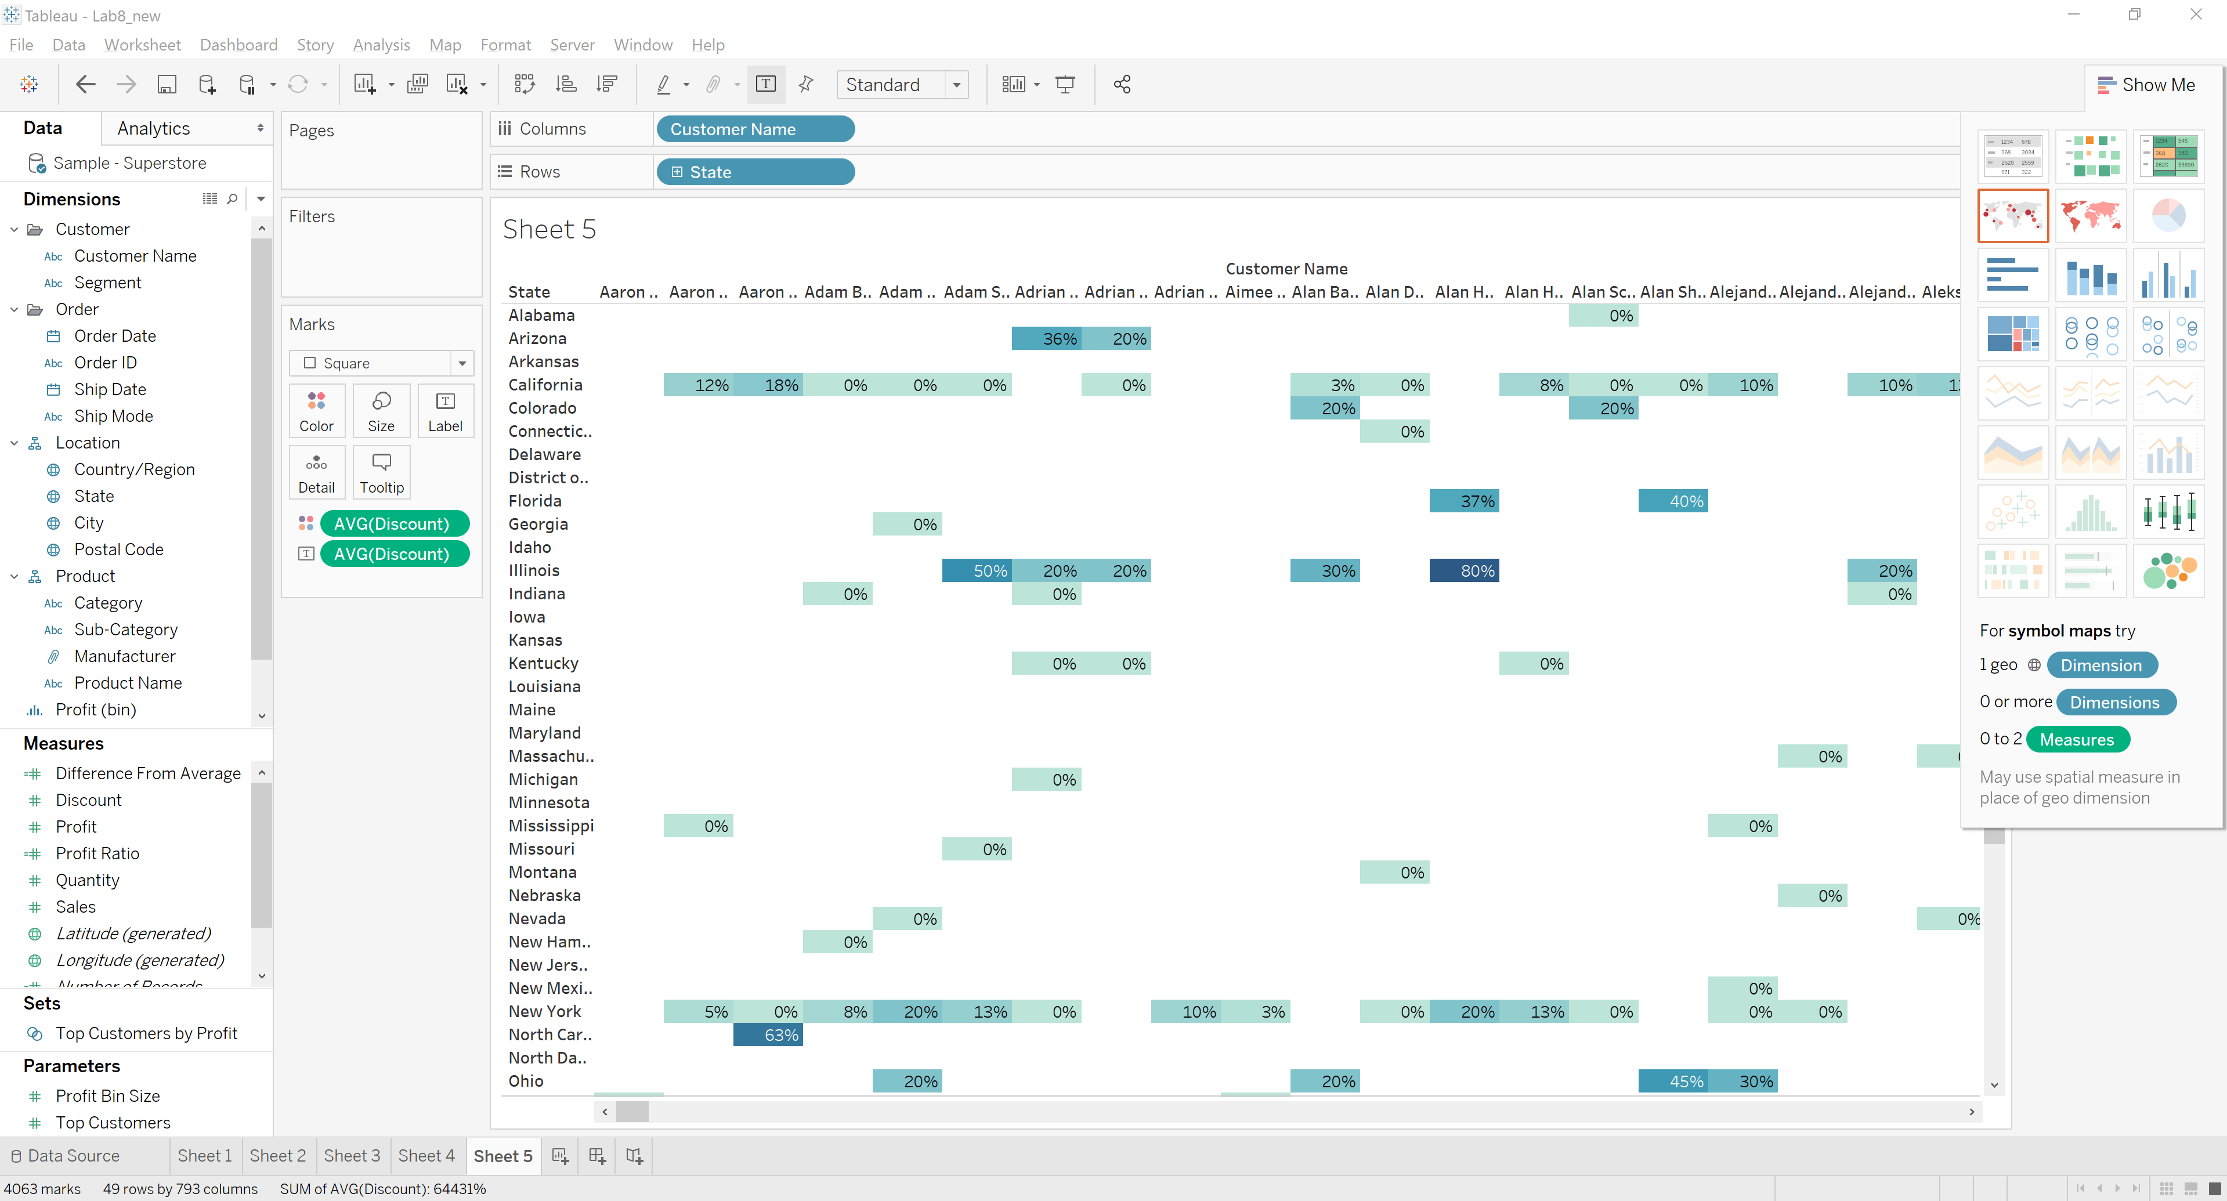

1. **Sum of Number of Records of each customer in each State (using tree maps and different color based on Number of Records):**

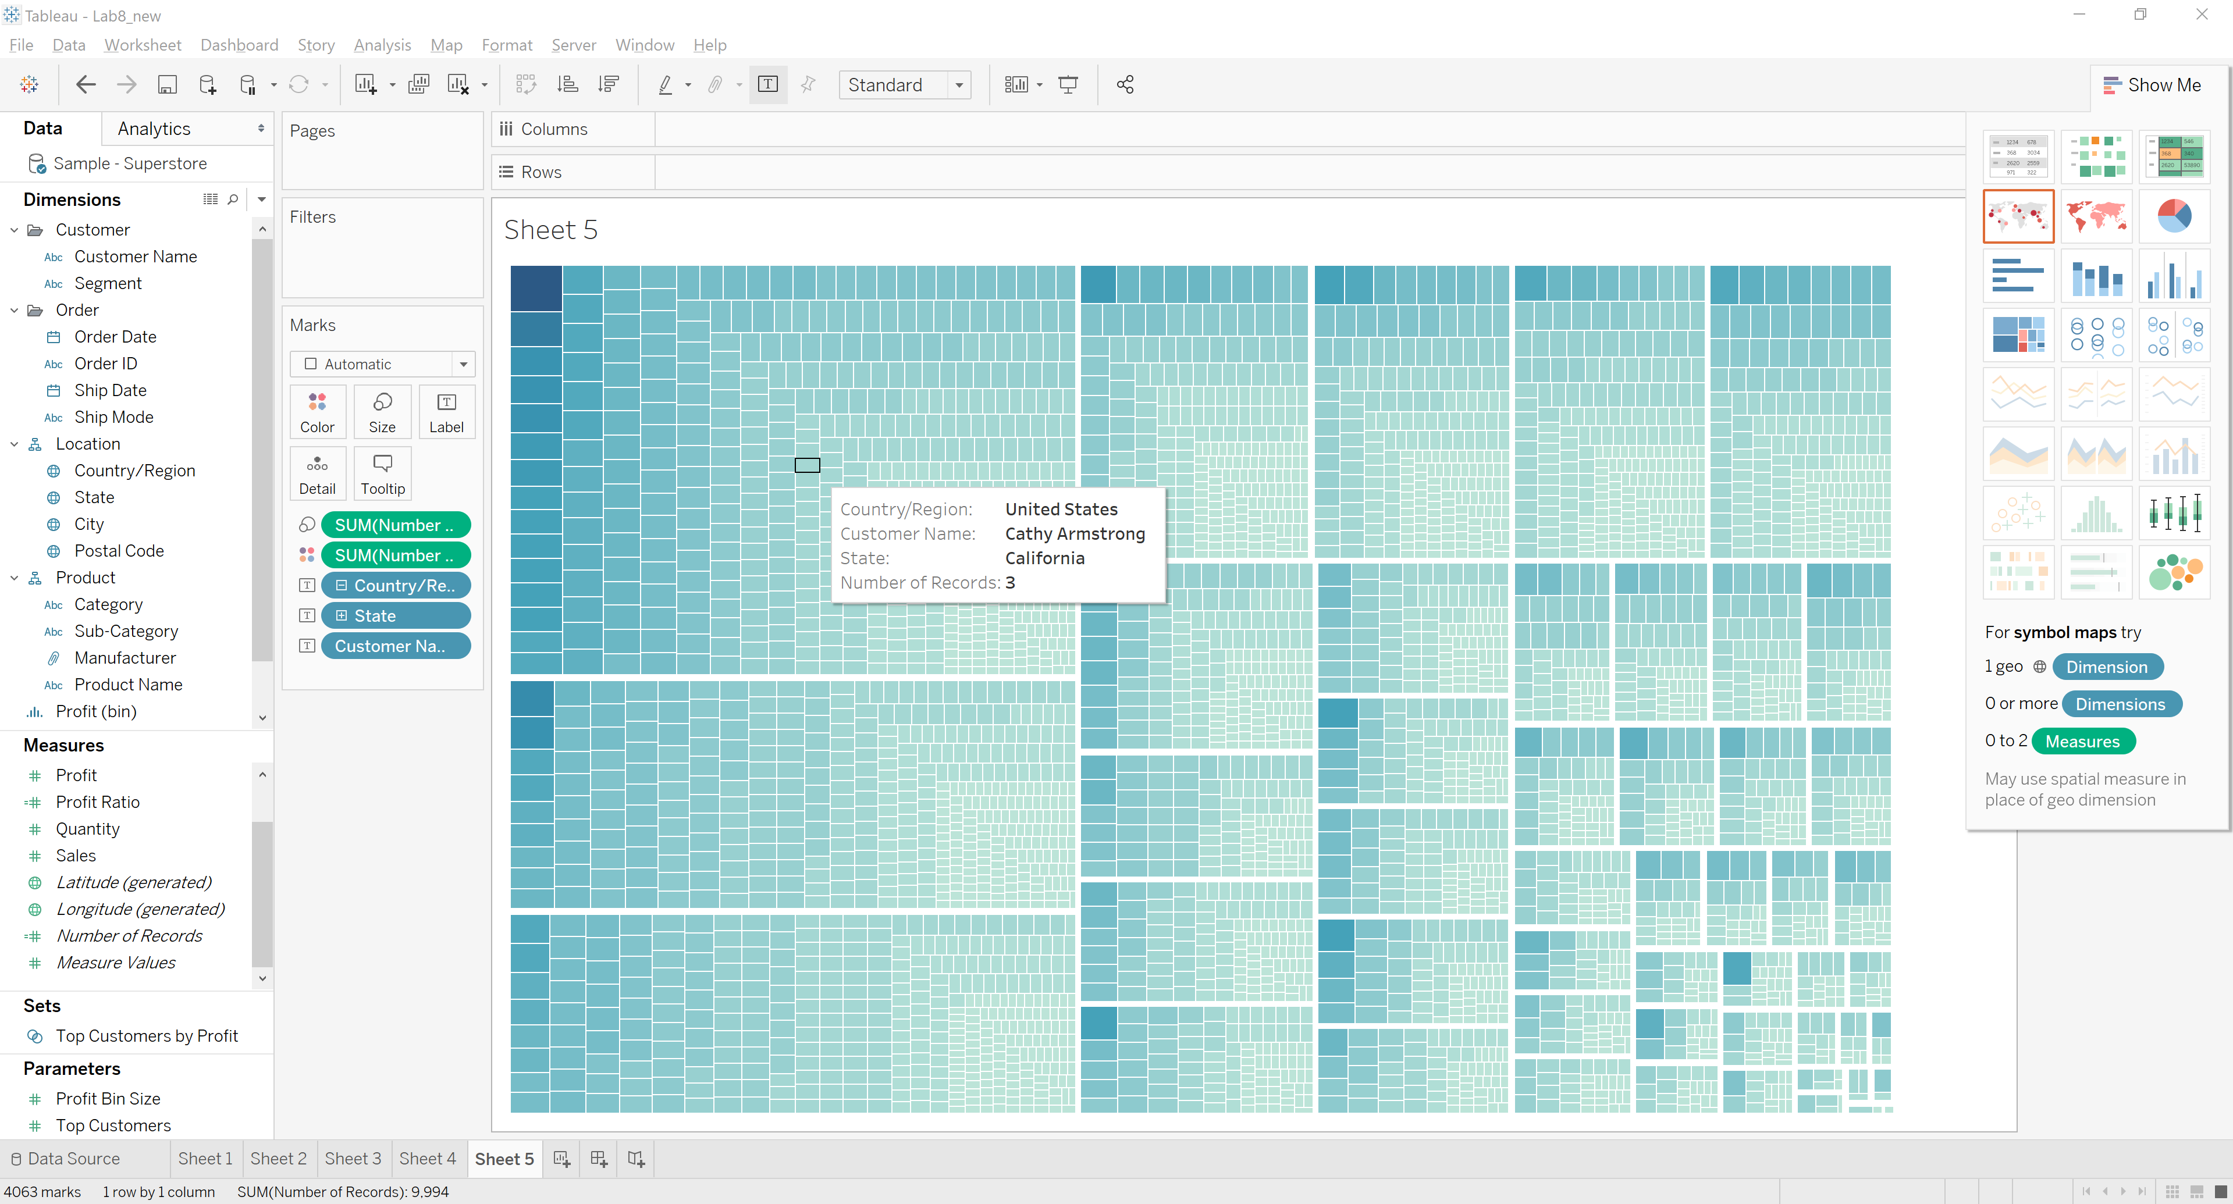

1. **Sum of Quantity vs Year of Order (Different colors based on Sub Category):**

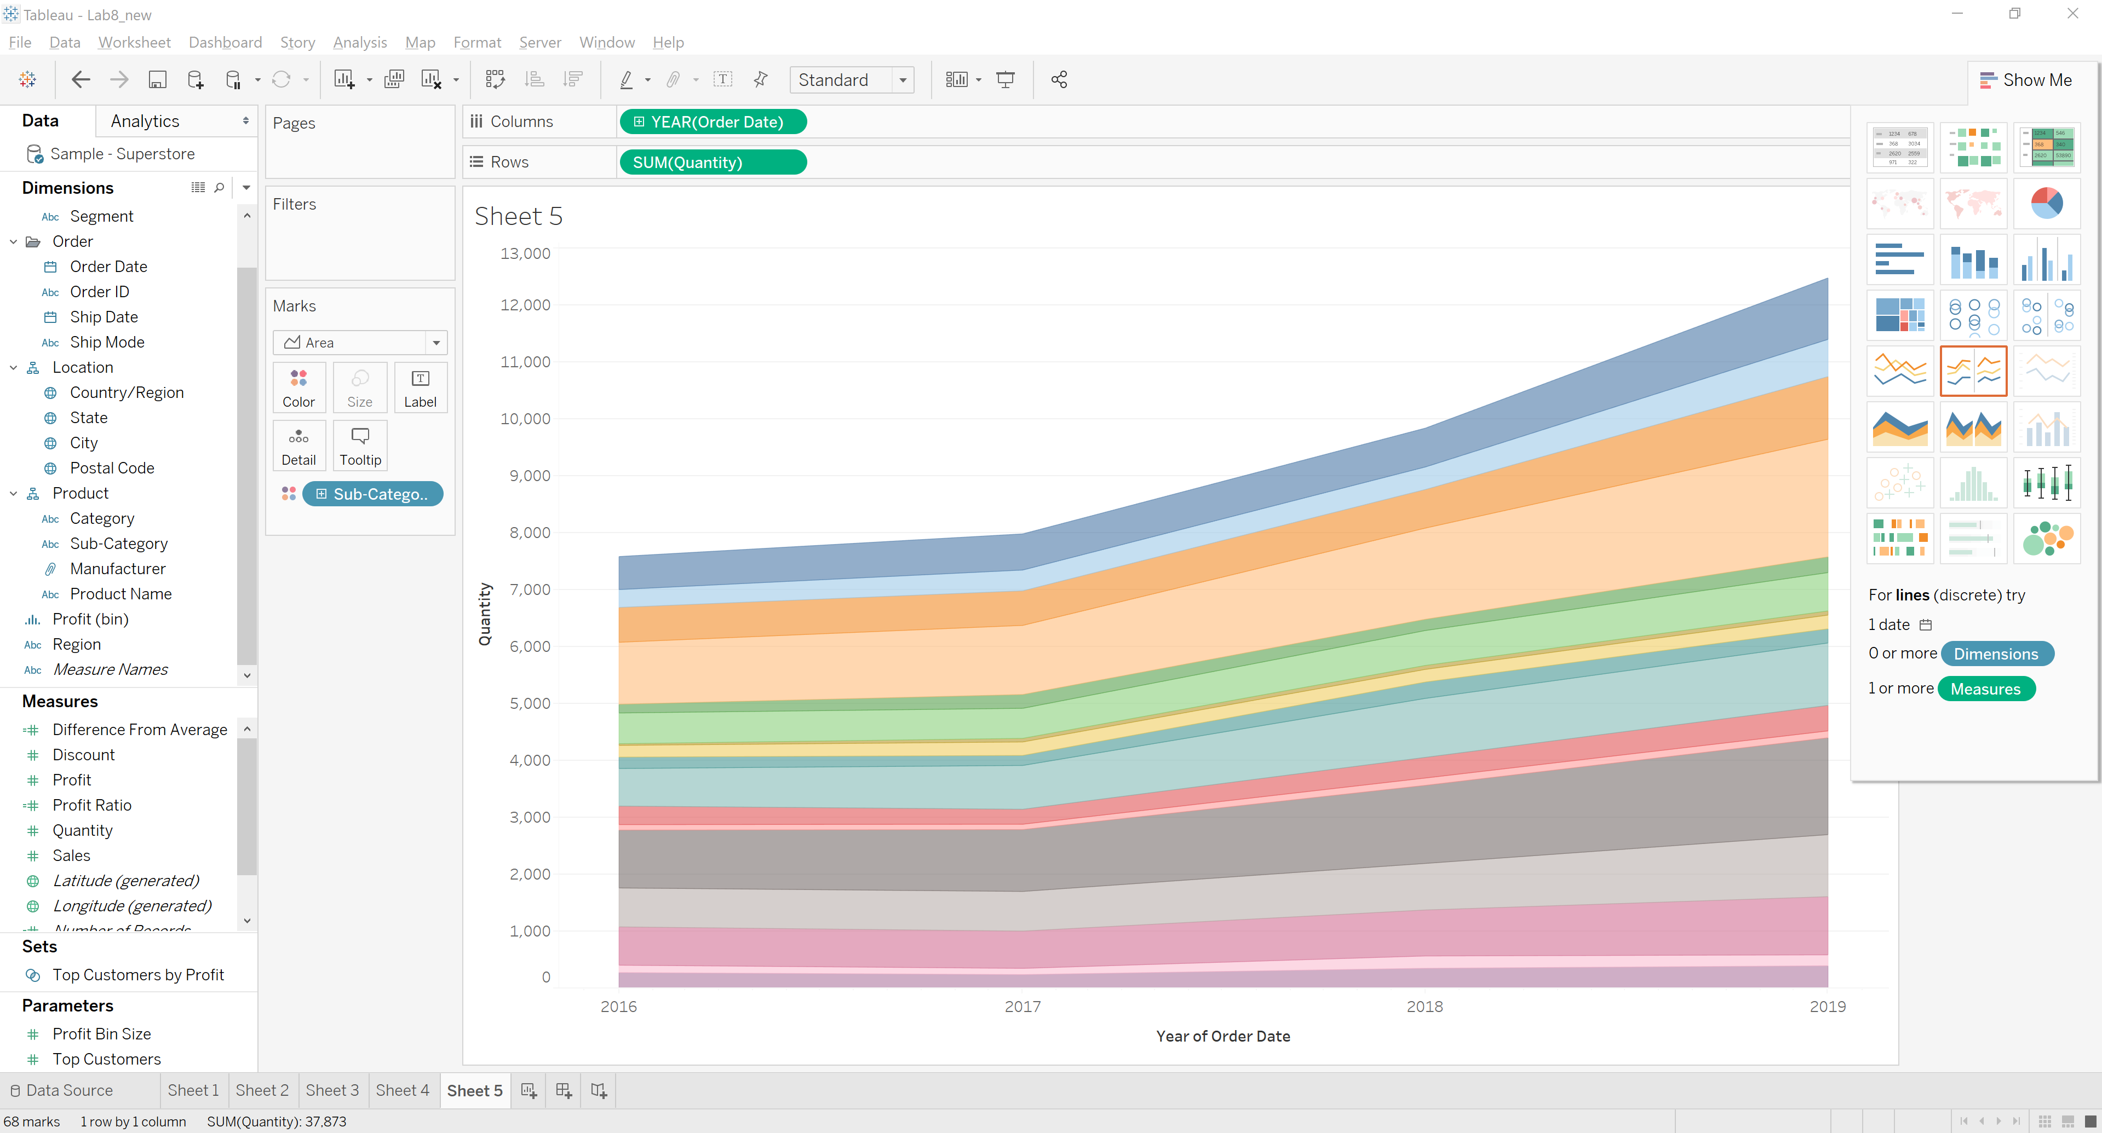

1. **Quantity of each sub category manufactured by different Manufacturers**

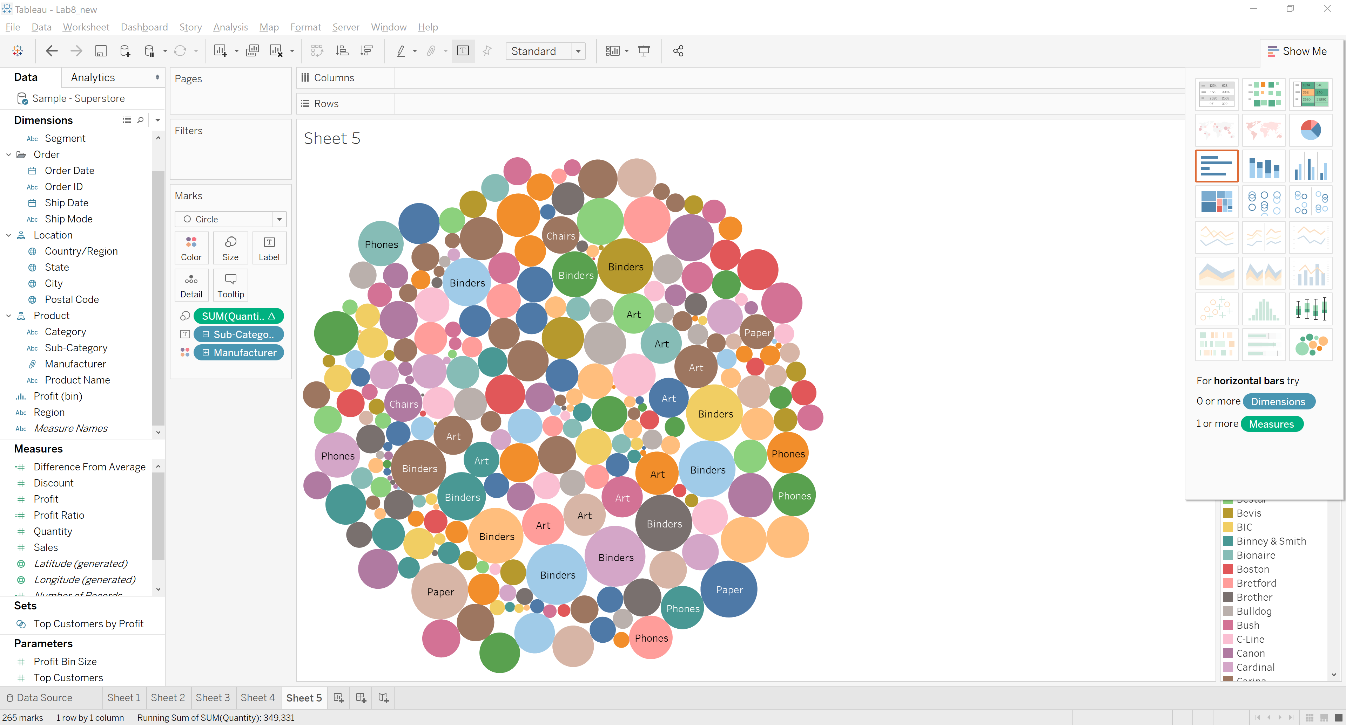

**Size: Quantity**

**Color: Manufacturer**

**Label: Sub Category**